SEC Form 4

FORM 4

Check this box if no longer subject to Section 16. Form 4 or Form 5 obligations may continue. See Instruction 1(b).

Check this box to indicate that a transaction was made pursuant to a contract, instruction or written plan for the purchase or sale of equity securities of the issuer that is intended to satisfy the affirmative defense conditions of Rule 10b5-1(c). See Instruction 10.

UNITED STATES SECURITIES AND EXCHANGE COMMISSION
Washington, D.C. 20549
Washington, D.C. 20549 |  | OMB APPROVAL
STATEMENT OF CHANGES IN BENEFICIAL OWNERSHIP
STATEMENT OF CHANGES IN BENEFICIAL OWNERSHIP |  | OMB Number: | 3235-0287
 |  | Estimated average burden
Filed pursuant to Section 16(a) of the Securities Exchange Act of 1934 |  | hours per response: | 0.5
or Section 30(h) of the Investment Company Act of 1940
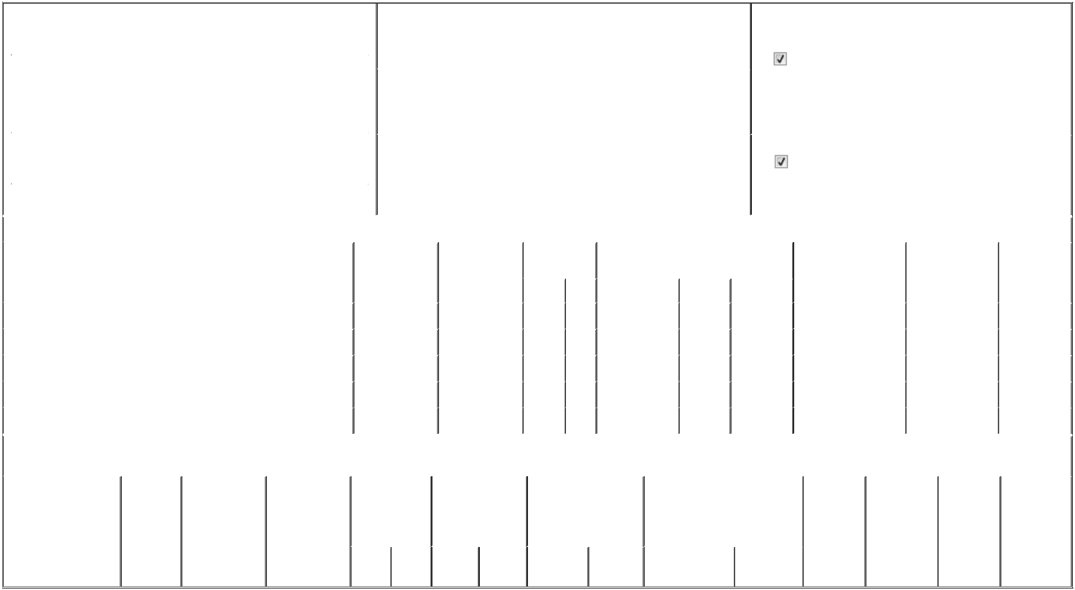

 | 1. Name and Address of Reporting Person* |  |  |  |  |  |  |  |  | 2. Issuer Name and Ticker or Trading Symbol |  |  |  |  |  |  |  |  |  | 5. Relationship of Reporting Person(s) to Issuer
 |  | Gilfillian Austen |  |  |  |  |  |  |  | Viper Energy, Inc. [ VNOM ] |  |  |  |  |  |  |  |  |  | (Check all applicable)
 |  | Gilfillian Austen |  |  |  |  |  |  |  |  |  |  |  |  |  |  |  |  |  |  |  | Director |  |  | 10% Owner
 |  |  |  |  |  |  |  |  |  |  |  |  |  |  |  |  |  |  |  |  |  | Officer (give title |  |  | Other (specify below)
 |  |  |  |  |  |  |  |  |  |  |  |  |  |  |  |  |  |  |  |  |  | below)
 |  | (Last) |  | (First) |  | (Middle) |  |  |  |  |  |  |  |  |  |  |  |  |  |  |  | below)
 |  |  |  | (First) |  | (Middle) |  |  |  | 3. Date of Earliest Transaction (Month/Day/Year) |  |  |  |  |  |  |  |  |  |  |  |  | President
 |  | 500 WEST TEXAS AVENUE
 |  |  |  |  |  |  | 03/01/2026
 |  | SUITE 100
 | (Street) |  |  |  |  |  |  |  |  | 4. If Amendment, Date of Original Filed (Month/Day/Year) |  |  |  |  |  |  |  |  |  | 6. Individual or Joint/Group Filing (Check Applicable Line)
 |  | MIDLAND |  | TX |  | 79701 |  |  |  |  |  |  |  |  |  |  |  |  |  |  |  | Form filed by One Reporting Person
 |  |  |  |  |  |  |  |  |  |  |  |  |  |  |  |  |  |  |  |  |  | Form filed by More than One Reporting Person
 |  | (City) |  | (State) |  | (Zip)
 |  |  |  |  |  | Table I - Non-Derivative Securities Acquired, Disposed of, or Beneficially Owned
 | 1. Title of Security (Instr. 3) |  |  |  |  |  | 2. Transaction |  |  |  | 2A. Deemed |  |  | 3. Transaction |  | 4. Securities Acquired (A) or Disposed Of |  |  |  |  | 5. Amount of Securities |  |  | 6. Ownership |  | 7. Nature of
 |  |  |  |  |  |  | Date |  |  |  | Execution Date, |  |  | Code (Instr. 8) |  | (D) (Instr. 3, 4 and 5) |  |  |  |  | Beneficially Owned |  |  | Form: Direct (D) or |  | Indirect
 |  |  |  |  |  |  | (Month/Day/Year) |  |  |  | if any |  |  |  |  |  |  |  |  |  | Following Reported |  |  | Indirect (I) (Instr. 4) |  | Beneficial
 |  |  |  |  |  |  |  |  |  |  | (Month/Day/Year) |  |  | Code | V | Amount |  | (A) or (D) | Price |  | Transaction(s) (Instr. 3 |  |  |  |  | Ownership
 |  |  |  |  |  |  |  |  |  |  |  |  |  | Code | V | Amount |  | (A) or (D) |  |  | and 4) |  |  |  |  | (Instr. 4)
 | Class A Common Stock |  |  |  |  |  | 03/01/2026 |  |  |  |  |  |  | A |  | 12,302⁽¹⁾ |  | A | $0 |  | 55,777 |  |  |  | D
 | Class A Common Stock |  |  |  |  |  | 03/01/2026 |  |  |  |  |  |  | F |  | 829⁽²⁾ |  | D | $46.54 |  | 54,948 |  |  |  | D
 | Class A Common Stock |  |  |  |  |  | 03/01/2026 |  |  |  |  |  |  | F |  | 2,645⁽³⁾ |  | D | $46.54 |  | 52,303 |  |  |  | D
 | Class A Common Stock |  |  |  |  |  | 03/01/2026 |  |  |  |  |  |  | F |  | 1,421⁽⁴⁾ |  | D | $46.54 |  | 50,882 |  |  |  | D
 | Class A Common Stock |  |  |  |  |  | 03/01/2026 |  |  |  |  |  |  | F |  | 1,614⁽⁵⁾ |  | D | $46.54 |  | 49,268 |  |  |  | D
 |  |  |  |  |  | Table II - Derivative Securities Acquired, Disposed of, or Beneficially Owned
 |  |  |  |  |  |  | (e.g., puts, calls, warrants, options, convertible securities)
 | 1. Title of Derivative |  |  | 2. | 3. Transaction | 3A. Deemed | 4. Transaction |  |  |  | 5. Number of |  |  | 6. Date Exercisable and |  |  | 7. Title and Amount of Securities |  |  |  |  | 8. Price of | 9. Number of |  | 10. | 11. Nature of
 | Security (Instr. 3) |  |  | Conversion | Date | Execution Date, | Code (Instr. 8) |  |  |  | Derivative |  |  | Expiration Date |  |  | Underlying Derivative Security |  |  |  |  | Derivative | derivative |  | Ownership | Indirect
 |  |  |  | or Exercise | (Month/Day/Year) if any |  |  |  |  |  | Securities Acquired |  |  | (Month/Day/Year) |  |  | (Instr. 3 and 4) |  |  |  |  | Security | Securities |  | Form: | Beneficial
 |  |  |  | Price of |  | (Month/Day/Year) |  |  |  |  | (A) or Disposed of |  |  |  |  |  |  |  |  |  |  | (Instr. 5) | Beneficially |  | Direct (D) or | Ownership
 |  |  |  | Derivative |  |  |  |  |  |  | (D) (Instr. 3, 4 and |  |  |  |  |  |  |  |  |  |  |  | Owned |  | Indirect (I) | (Instr. 4)
 |  |  |  | Security |  |  |  |  |  |  | 5) |  |  |  |  |  |  |  |  |  |  |  | Following |  | (Instr. 4)
 |  |  |  |  |  |  |  |  |  |  |  |  |  |  |  |  |  |  |  |  |  |  | Reported
 |  |  |  |  |  |  |  |  |  |  |  |  |  |  |  |  |  |  | Amount or |  |  |  | Transaction(s)
 |  |  |  |  |  |  |  |  |  |  |  |  |  | Date |  | Expiration |  |  | Number of |  |  |  | (Instr. 4)
 |  |  |  |  |  |  | Code V |  |  |  | (A) | (D) |  | Exercisable |  | Date | Title |  | Shares

Explanation of Responses:

- These securities are restricted stock units, each representing a contingent right to receive one share of Class A Common Stock, par value $0.000001 per share, of the issuer. These restricted stock units were granted under the issuer's equity incentive plan and will vest in three equal installments beginning on March 1, 2026.

- The issuer withheld shares of Class A Common Stock that would have otherwise been issuable to the reporting person to satisfy the issuer's tax withholding obligations in connection with the vesting and settlement on March 1, 2026 of the third tranche of the time-based restricted stock units granted to the reporting person on March 1, 2024. The number of shares of Class A Common Stock withheld was determined based on the closing price per share of the issuer's Class A Common Stock on February 27, 2026.

- The issuer withheld shares of Class A Common Stock that would have otherwise been issuable to the reporting person to satisfy the issuer's tax withholding obligations in connection with the vesting and settlement on March 1, 2026 of the second tranche of the time-based restricted stock units granted to the reporting person on December 20, 2024. The number of shares of Class A Common Stock withheld was determined based on the closing price per share of the issuer's Class A Common Stock on February 27, 2026.

- The issuer withheld shares of Class A Common Stock that would have otherwise been issuable to the reporting person to satisfy the issuer's tax withholding obligations in connection with the vesting and settlement on March 1, 2026 of the second tranche of the time-based restricted stock units granted to the reporting person on March 1, 2025. The number of shares of Class A Common Stock withheld was determined based on the closing price per share of the issuer's Class A Common Stock on February 27, 2026.

- The issuer withheld shares of Class A Common Stock that would have otherwise been issuable to the reporting person to satisfy the issuer's tax withholding obligations in connection with the vesting and settlement on March 1, 2026 of the first tranche of the time-based restricted stock units granted to the reporting person on March 1, 2026. The number of shares of Class A Common Stock withheld was determined based on the closing price per share of the issuer's Class A Common Stock on February 27, 2026.

Remarks:

Exhibit List: Exhibit 24.1 - Limited Power of Attorney

 | /s/ William F. Krueger, as attorney-in- |  |  | 03/03/2026
 | fact for Austen Gilfillian
 | ** Signature of Reporting Person |  |  | Date
Reminder: Report on a separate line for each class of securities beneficially owned directly or indirectly.
* If the form is filed by more than one reporting person, see Instruction 4 (b)(v).
** Intentional misstatements or omissions of facts constitute Federal Criminal Violations See 18 U.S.C. 1001 and 15 U.S.C. 78ff(a).
Note: File three copies of this Form, one of which must be manually signed. If space is insufficient, see Instruction 6 for procedure.
Persons who respond to the collection of information contained in this form are not required to respond unless the form displays a currently valid OMB Number.



